Mood Board/Art Concepts:

Mansion:

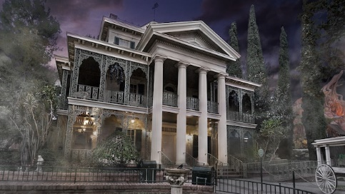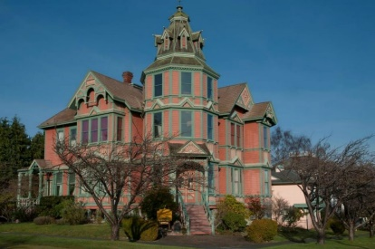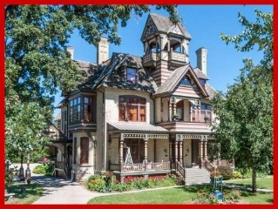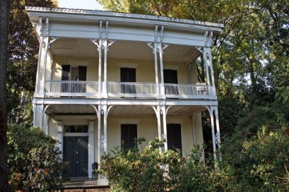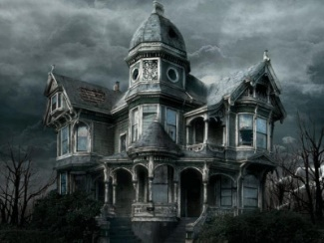

Character:

Haunted Mansion. (2017). [image] Available at: https://disneyland.disney.go.com/attractions/disneyland/haunted-mansion/ [Accessed 31 Oct. 2017].

Randall, J. (2017). *Ann Starrett Mansion*. [image] Available at: http://www.sheknows.com/home-and-gardening/articles/1055865/spookiest-haunted-mansions-to-ever-hit-the-real-estate-market [Accessed 31 Oct. 2017].

Randall, J. (2017). *McRaven Tour Home*. [image] Available at: http://www.sheknows.com/home-and-gardening/articles/1055865/spookiest-haunted-mansions-to-ever-hit-the-real-estate-market [Accessed 31 Oct. 2017].

Randall, J. (2017). *The Allyn Mansion*. [image] Available at: http://www.sheknows.com/home-and-gardening/articles/1055865/spookiest-haunted-mansions-to-ever-hit-the-real-estate-market [Accessed 31 Oct. 2017].

Haunted Mansion. (2017). [image] Available at: http://www.scaryforkids.com/haunted-mansions/ [Accessed 31 Oct. 2017].